Image | 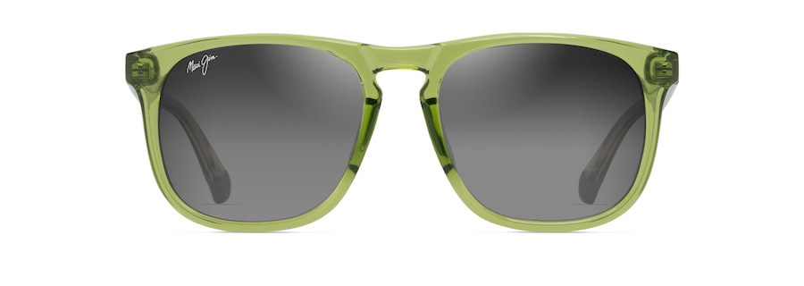
Brand | MAUI JIM
Model Name | KŪPA‘A
Price | RS 3490
PRODUCT DETAILS

